**CSC 120.0003 Module 8 Lab – Benjamin Steele**

**Question 1.**

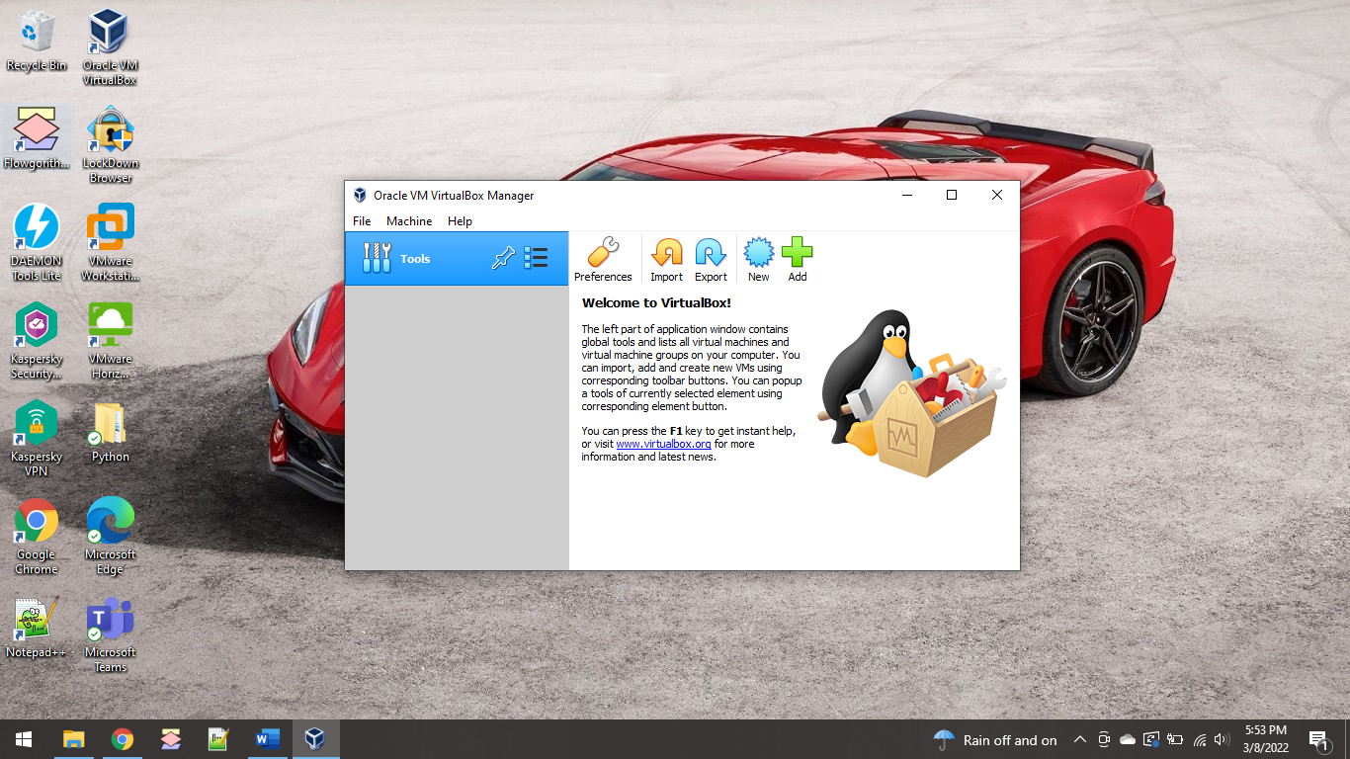

**Question 2.**

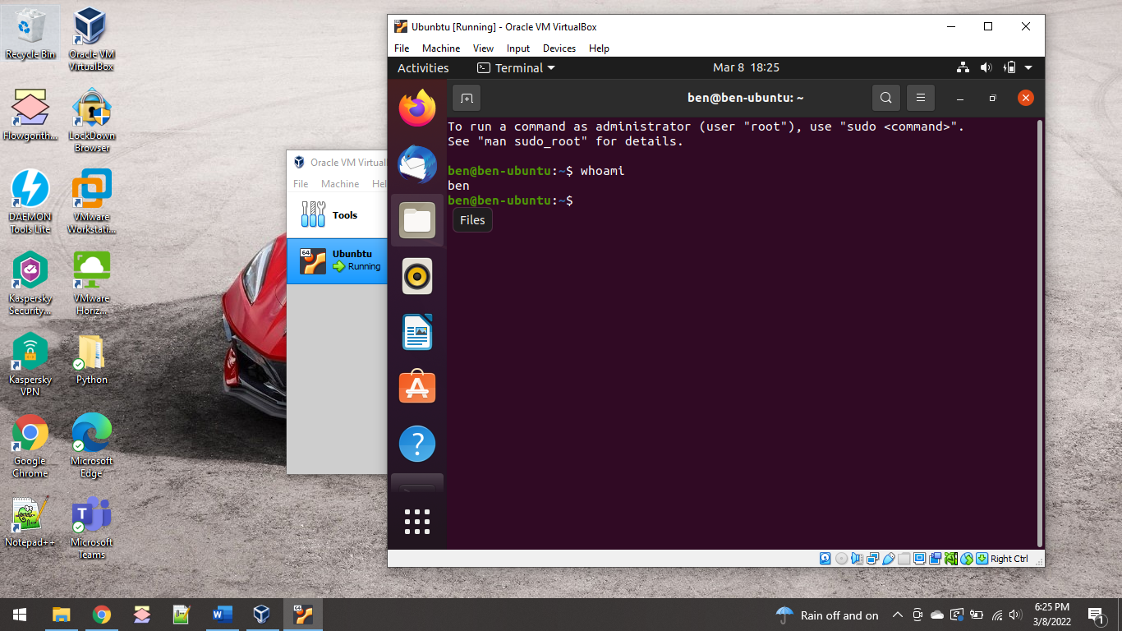

**Question 3.**

**a.**

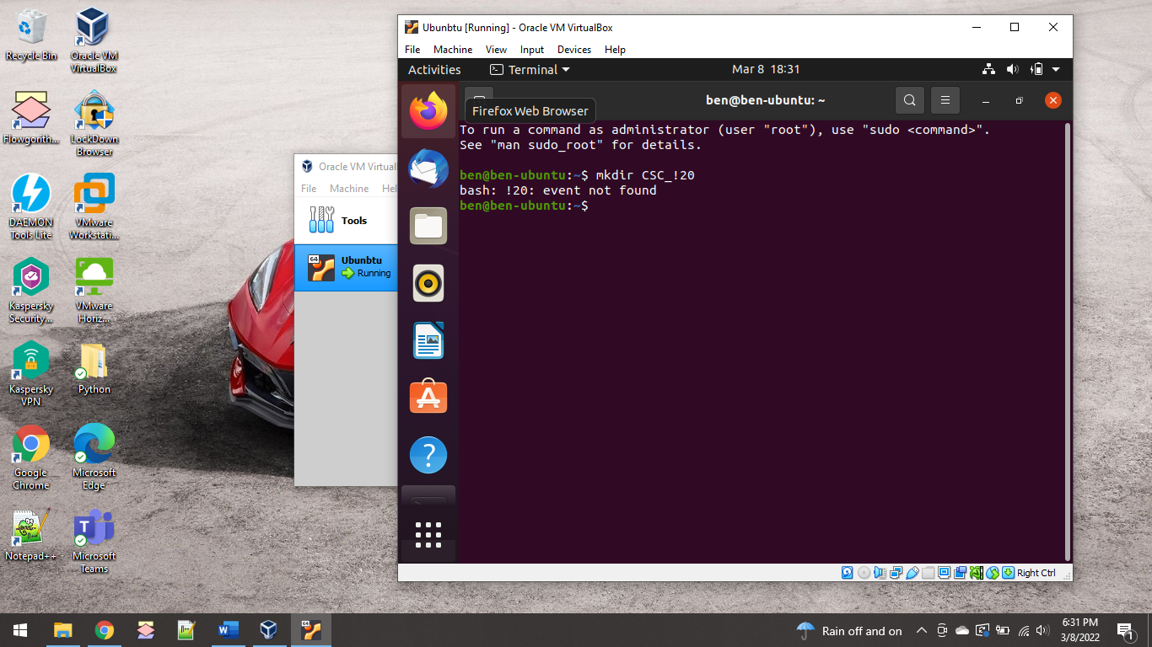

**b.**

The “ls” command in Linux lists the contents of a directory. This is the equivalent to seeing folders in the GUI Files app. There are a lot of different parameters that can be used with this command to get more details of the permissions, last write date, and checking contents of other directories or subdirectories.

**c.**

The “cd” command in Linux changes the directory you are in to one of your choice. You can either choose to use absolute or relative names, choose to change directories one at a time, or select a specific directory to move to.

**e.**

I used the command “sudo apt-get install vlc” to install VLC player.

**f.**

The output of the pwd command was /home/ben. The pwd command prints the current working directory. This shows you which folder you are currently in.

**Question 4.**

A virtual machine is a full computer operating system that runs on another computer by sharing its hardware resources, it’s host. Comparatively, a host operating system is directly installed onto the hardware of a computer. A host operating, or hypervisor, is required for a virtual machine to be created. The hypervisor can be one of two types – a piece of software installed on an existing host operating system that manages the hardware resources and provides graphical access to the virtual machine, or the operating system itself can be a hypervisor in that its primary purposes is to manage hardware resources for use on many virtual machines.

Technology companies today can utilize these features by creating virtual machines in the cloud, and accessible anywhere on the internet, barring firewall rules. A company like VMware can have cloud hardware allocated specifically for use as hypervisors in which they can provide the services to other companies. In addition, other technology companies like Microsoft, Azure can also be utilized for its cloud hardware resources. Combining all these technologies together allows a company to use hardware in the cloud, hosted by other technology companies, for use as hypervisors and install virtual machines so that a user’s virtual desktop can be accessible from anywhere.

**Question 5.**

A process is the underlying execution of a program. When a program or application is opened, a process starts that maintains the running of the application. The kernel assigns a process ID to the process so that it can keep track of each different process separately. The CPU executes these processes one at a time using a time slice, which a is a specific very small period of time allocated to the process so that it can be executed.

System software is used to maintain hardware resources and is essential for allowing application software to run. Application software is any type of software that is used for varying specific purposes. The system software is the interface used to allow applications to run on system hardware and tends to be written in a lower programming language. For example, Microsoft Word is an application software and requires multiple pieces of system software for it to run successfully. These required system software could be the drivers needed to display the GUI onto the screen or those needed for the keyboard interaction with Microsoft Word.

**Question 6.**

# Find all pairs in the list

# scores = [40, 91, 85, 15]

scores = []

r = int(input("How many scores do you have? "))

for i in range (r):

score = int(input("Enter a score: "))

scores.append(score)

print("Here are all the pairs of scores:")

for s in scores:

for n in scores:

if scores.index(s) > scores.index(n):

continue

elif n != s:

print(s, n)

<https://colab.research.google.com/drive/1O4gOMS1IbpPxzzfP__7lXCyN55oWuVBb?usp=sharing>

**Extra Credit**

# Extra Credit

# Find all unique characters in a string.

# The question does not indicate whether upper and lower case are considered different characters. So # this application considers them unique.

# s = "i_love_programming_in_python_and_i_will_alzways_program"

s = input("Please enter a string: ")

stringLetters = {}

for c in s:

if c in stringLetters:

stringLetters[c] = stringLetters[c] + 1

else:

stringLetters[c] = 1

print("The unique characters in this string are:")

for l in stringLetters:

if stringLetters[l] == 1:

print(l)

<https://colab.research.google.com/drive/1O4gOMS1IbpPxzzfP__7lXCyN55oWuVBb?usp=sharing>